Language Immersion Camp
Cazorla 2024

25h July – 1st August 2024
Dear students and parents,
Further to the success of the Language Immersion Camp for six summers, we will return to Cazorla which proved to be a very successful and dynamic camp. Cazorla is located the south of Spain, in the middle of a privileged Natural Park, surrounded by rivers and lakes.
Once again, the project's aim would be to integrate the students in a camp with Spanish kids so they will be closely working with the Spanish teachers and children, listening and interacting in a rotation system. At the end of the morning they will be working with me making sure that all the topics needed for their Spanish GCSE/ A-Levels will be covered.
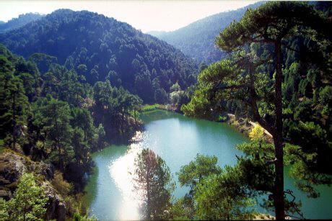
As I have been teaching and researching the learning of Spanish, working with fully bilingual children for more than 20 years now, I fully believe a week of Language Immersion Camp properly directed would be highly beneficial for Spanish language learners. This unique opportunity will build confidence and secure a working language knowledge impossible to achieve in a weekly lesson sitting behind a desk.

Sierra de Cazorla – Aula de naturaleza el Hornico
This camp is located in the "Sierra de Cazorla" a natural park in the eastern part of the province of Jaén, Andalucía, Spain. It is the largest protected area in Spain and the second largest in Europe.
El Hornico Campamento en Cazorla
Facilities
The buildings belong to a refurbished "cortijo" and has been working as a camp for more than 20 years, receiving mainly Spanish students or nature groups. The rooms have 6-8 beds with own bathrooms. The camp has their own kitchen facilities and a dining room. They will serve 4 meals a day, breakfast, lunch, tea and dinner. They will offer a Mediterranean diet, catering for allergies / religious / vegetarian dishes. All the meals will consist of first and main dish, bread, water and desert. The camp has lots of facilities for many different activities including a swimming pool and a medical room.
There is also connection to WIFI and the students will be allowed the mobiles at around 8pm for one hour. However, during the main part of the days, the mobiles will be stored securely. In case of emergency a mobile phone will be provided to the parents from which we will keep you updated daily. You can contact us on that phone any time day or night, and in the case of an emergency we will contact you from that phone.
The rooms will be cleaned daily. All the monitors are qualified, holding a Spanish equivalent of a DBS and the students will be fully insured. All the equipment will be supplied. Our students will have to interact in Spanish and listen attentively, as there will be lots of enterprises going on. The monitors in the camp are all qualified, but the team from Olé, will be spending one hour every day with a formal lesson to continue the more academic approach and get these GCSEs and A levels revised.

Some Images of the Camp
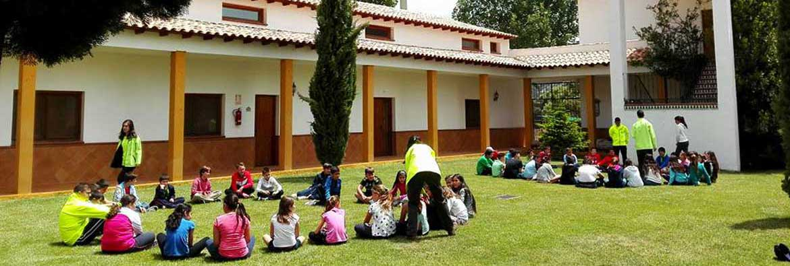
The camp

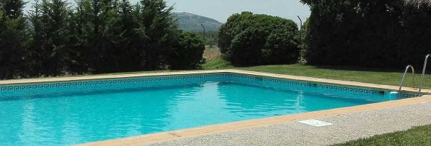
Swimming pool

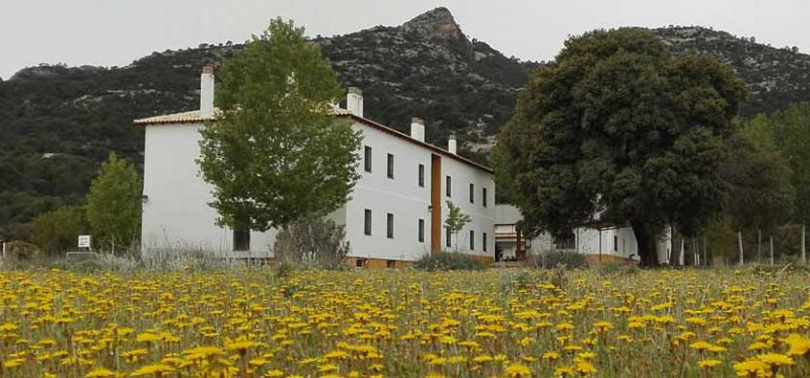
Camp

Activities
Like in previous trips, the idea is to introduce the students to the language and be exposed during the whole time to Spanish. We will not go sightseeing, as this is an opportunity for the English students to get together and chat in English. At the camp there will be constant fun events
You can see a list of the activities we did last year and that we will be doing besides new ones and please find in the glossary the example of a day in the camp, so you can get an idea of how the time will be spent in the camp.
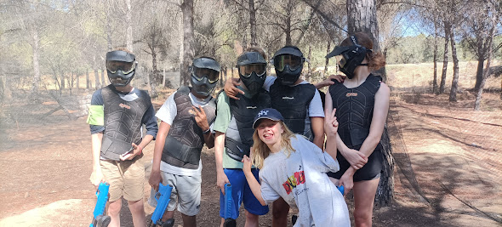
Many cool activities
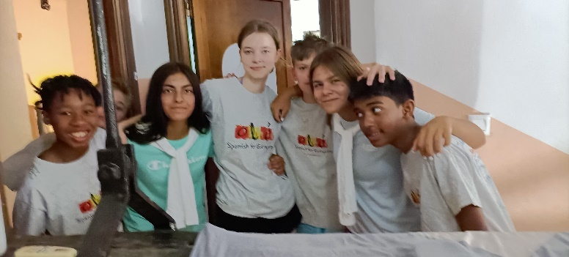
Friends forever Spanish and English kids
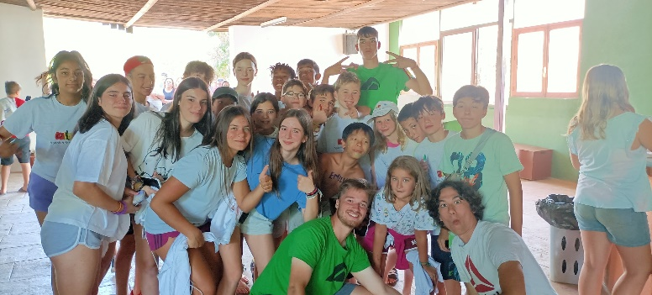
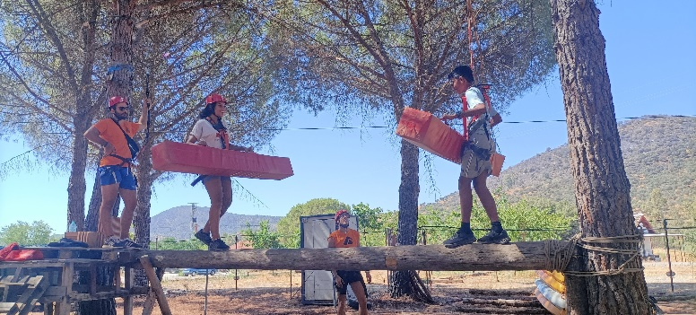
Walking on the trees
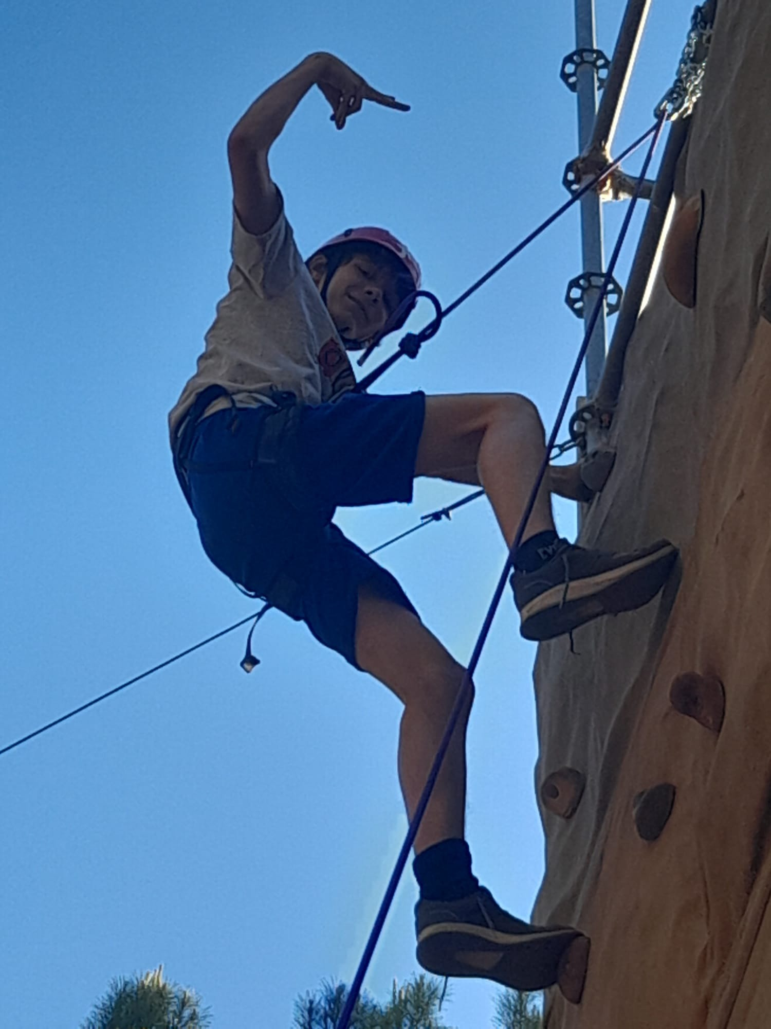

List of Activities
- Canoeing
- Archery
- Blowpipe
- Slingshots
- Bowling
- Zip wire circuit
- Orienteering/ hiking
- Rock climbing
- Paddle Surf
- Team Sports
About the Spanish
he Price
Therefore, the price for 7 days of camp, full board and all listed activities, flights, transfer to and from Sevilla Airport and transfers from Ole Spanish’s Head Office to Stansted Airport and back to London N20. All students will receive a T-shirt that they will wear for our travels. The price will be £1150.
This program is offered to all the students of Olé Spanish for Everyone and the places are assigned in a first come, first served basis. We welcome siblings or friends who want to take advantage of this opportunity, but they will be expected to behave in a considerate manner.
The places will be booked in a first come, first served basis and we expect it to get full very quickly this year as Ole Spanish has expanded considerably. If you are interested, please do send us an email on admin@olespanish.net or give us a call on 07932781290.
If you have any questions, please do not hesitate to contact us at any time.

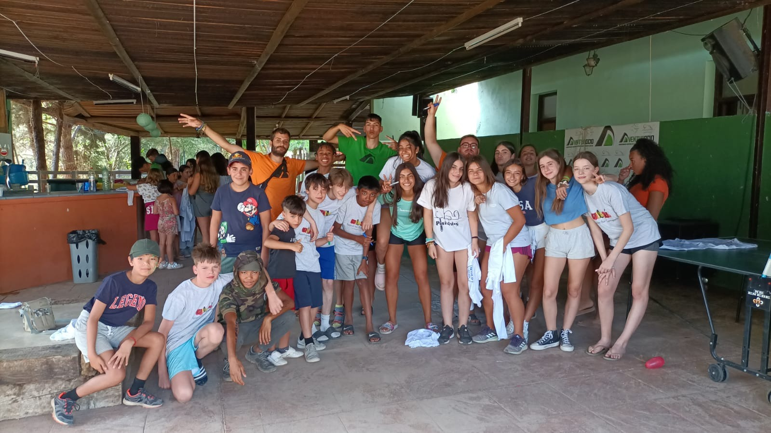
TIME AND TYPE OF ACTIVITY

8:15 Good morning
9:00 Breakfast
9:30 Organising the rooms
MORNING ACTIVITIES
10:00 Morning activity
14:00 Lunch and rest

AFTERNOON ACTIVITY
15:30 Swimming pool
16:45 Tea Time
17:00 afternoon activity.
19:00 Spanish Lesson with Ole
20:00 Telephone time
21:00 Dinner

NIGHT ACTIVITIES
22.00 Night Activity
23.30 Good night

